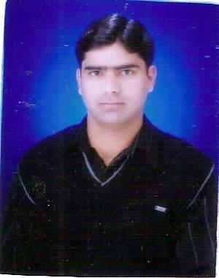

Eftikhar Hidayatullah Mangi
Najam Medical store, old bus stand, shahabad Mohalla Larkana.
Mob: 0300-4330486, 0333-3590830 Email:iftimangi.9409@gmail.com

Objective | - To seek a challenging and result oriented career in the areas of Management, accounting and finance, where I can utilize my professional skills and experience.  I am a young, motivated and skilled professional. Presently, I am working as Manager Operations in a leading Microfinance Institute, registered under Company’s Act Section-42 (SECP). My career as financial professional is spread over last seven years in the field of financial services, administrations, HR, management, budgeting, monitoring and evaluation. During this period I have worked and can work effectively in the multicultural set up.  I have been fortunate enough to have privilege to attend the several trainings and workshops on Project Designing, Project Management, Financial Management, Funds Management, Internal Control & Risk Management, credit assessment, Deliquency management.
Personal Details | - Father’s Name: Late Hidayatullah Mangi  - NIC No: 43203-9502283-1  - Date of Birth: 17/03/1981  - Religion: Islam  - Nationality: Pakistani  - Place of Birth: Larkana  - Marital Status: Single  - Computer: MS Word, Excel, Power point, MS Access &  Internet &e-mails  - Languages: English, Urdu & Sindhi (Effective writing and  Communicating Skills.
Experience | Manager Operations  Credit & Enterprise Development Sector ( SAFWCO)  October 2008 to date.  - Supervise entire operations of Microfinance Program of the sector. Planning budgeting, monitoring and developing & projecting business plans.  - Responsible for monthly, Quarterly target setting and ensure achievements of all the Assigned targets at branch & region level.  - Responsible for credit approvals and credit administrations and ensure credit Operations, documentations and quality of disbursements.  - Ensure implementation of all operations, credit, and HR and Admin policies at branch and region level.  - Develop, design and formulate parameters, checklist and measures for branch and region’s productivity and efficiency.  - Identify key risk areas & issues related with MF program and to provide necessary input & directions to cover those issues for smooth operations.  - Signatory of all the bank accounts at branch and region level. Correspondence & coordination with the Donor & delegations.  - Assess and preserve all sorts of MIS reports for performance review and formulation of future road map.  Customer Relationship Manager ( BM)  October 2007 – Sept. 2008  Pakoman Microfinance Bank Ltd.  Customer Services Officer ( AM)  Khushhali Bank Ltd.  May 2004 – Sept. 2007
Workshops | Training & Workshops:  - Skilled Enhancement Training at HDI Khushhalibank Islamabad in 2005.  - Training on delinquency and default management.  - Product development & management in 2005  - Two days workshop on Monitoring & Evaluation in 2006.  - Two days workshop on Compliance in 2006.  - Product research & Product Development.  - Art of client’s Appraisals & social mobilization.  - Credit Operations & management.  - Risk management & internal control requirements.
Computer Skills | • One year Diploma in computer Science  with MS word & MS Excel, Internet, E-mails
Qualifications | Qualifications:  MBA Finance  SALU, Khairpur , Sindh  CGPA - 3.5.  MA Economics  SALU, Khairpur , Sindh  1st Class.  BA Economics  SALU, Khairpur, Sindh  1st Class.  H.S.C II Pre-Med  Cadet college Larkana.  A – Grade.  S.S.C II Science  Cadet college Larkana  A – Grade.
Reference | Would be furnished upon demand.

